**Diametrical Magnetization:**

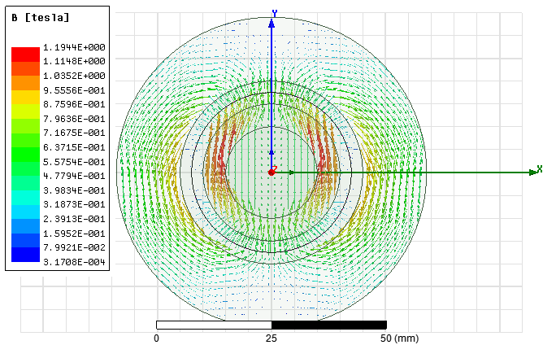

Figure 1: Magnetic flux vectors for diametrical magnetization

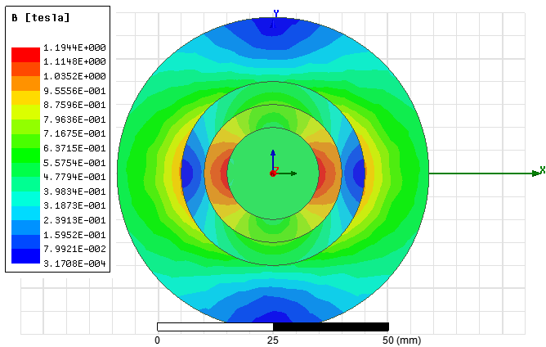

Figure 2: Magnetic flux density for diametrical magnetization

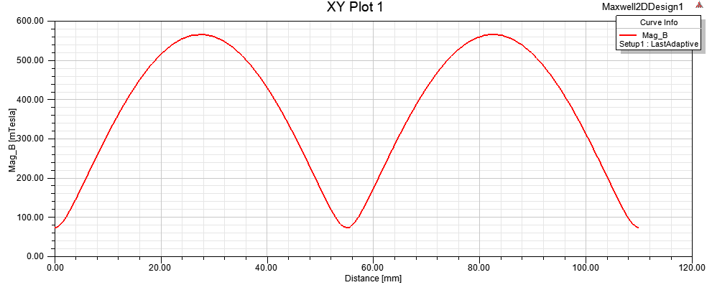

Figure 3: Radial flux density in the center of the air gap for diametrical magnetization

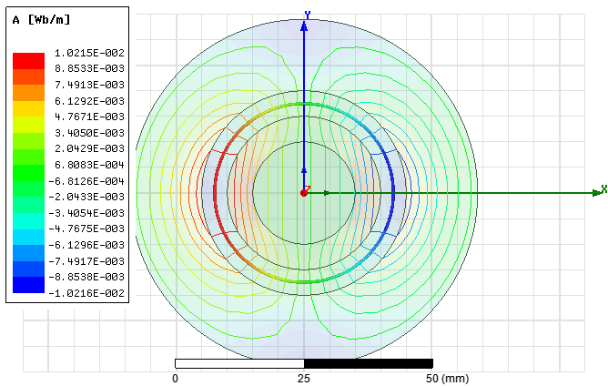

Figure 4: Flux lines for diametrical magnetiation

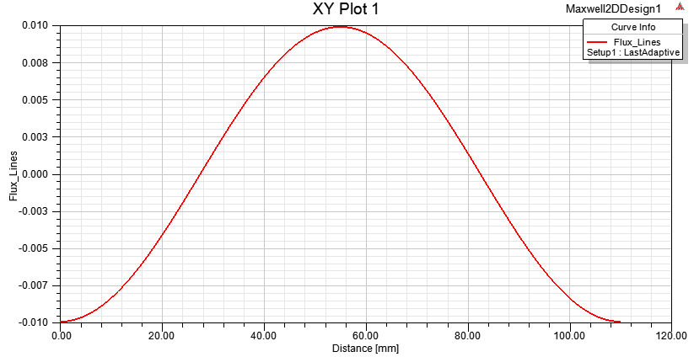

Figure 5: Flux lines in the center of the air gap for diametrical magnetization